Design Specification
Version:
October 22, 2006
Document ID: My_Project_DESIGN_SPEC
Group Name:
Editor:
Group Members:

Approved:
Date:
Table of Contents
Version History ii
1.0 Introduction 2
2.0 Packages 2
3.0 Class Diagrams 2
4.0 Interaction Diagrams 2
5.0 Class Specifications 2
6.0 Summary 2
7.0 References 2

Version History
Issue | Date | Change

Introduction

Packages

The Employment Management sub-system has four packages that together keep track of employee records, enforce system security, assign and manage tasks given to employees, and pay employees.
Below is a short description of each package and their basic purpose.

Package Name | Description
Payroll | The payroll package represents the management of payments (either in the form of salaries or wages) to employees, including deducting tax and benefits.
Task management | This package is used for the creation, allocation, and management of employee tasks; employees who have been assigned tasks have the ability to record their progress in the task and mark it as completed.
Security | This package ensures that employees only get access to those system actions to which they are allowed, as well as providing an interface for employees to login and logout of the system and recording/retrieving security logs.
Human resources | This part of the system takes care of employee records, allowing viewing, creation and updating. Human resources staff are the only ones who have access to this system.
People | This package gives an overview of the relationships between people in the system.

Class Diagrams

System Package
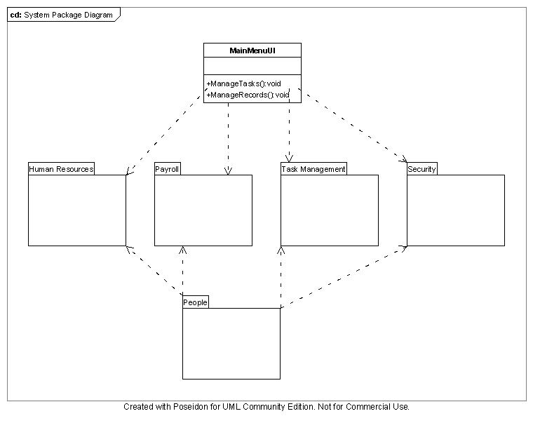
People Package

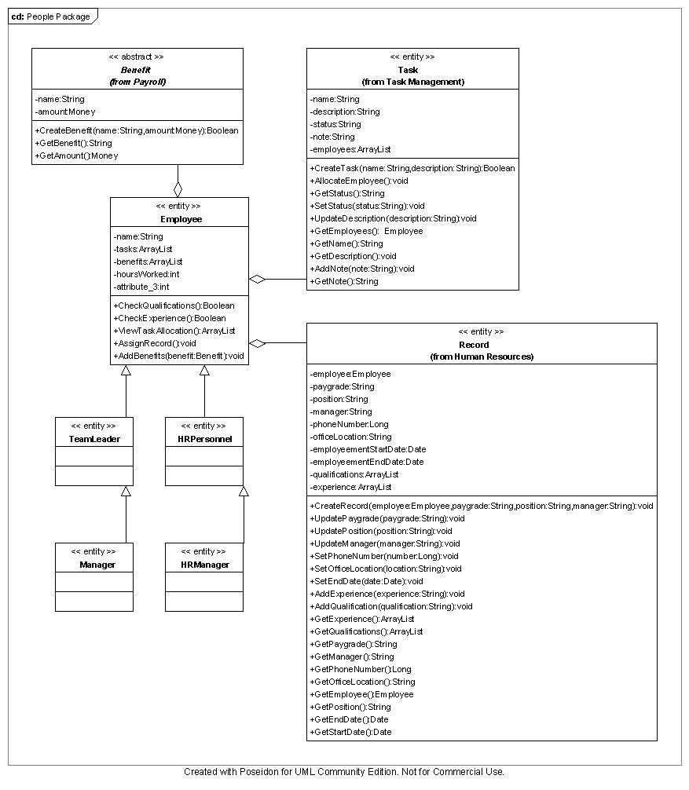

Task Management Package

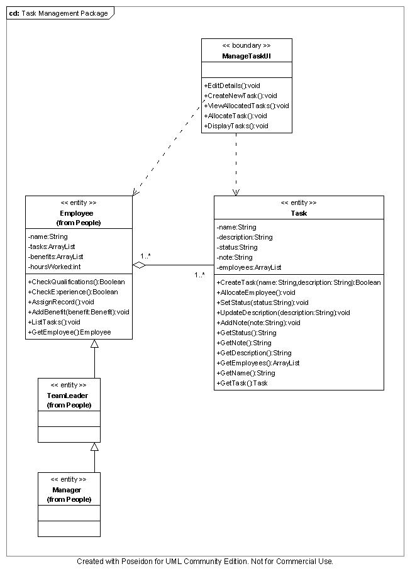

Human Resources Package

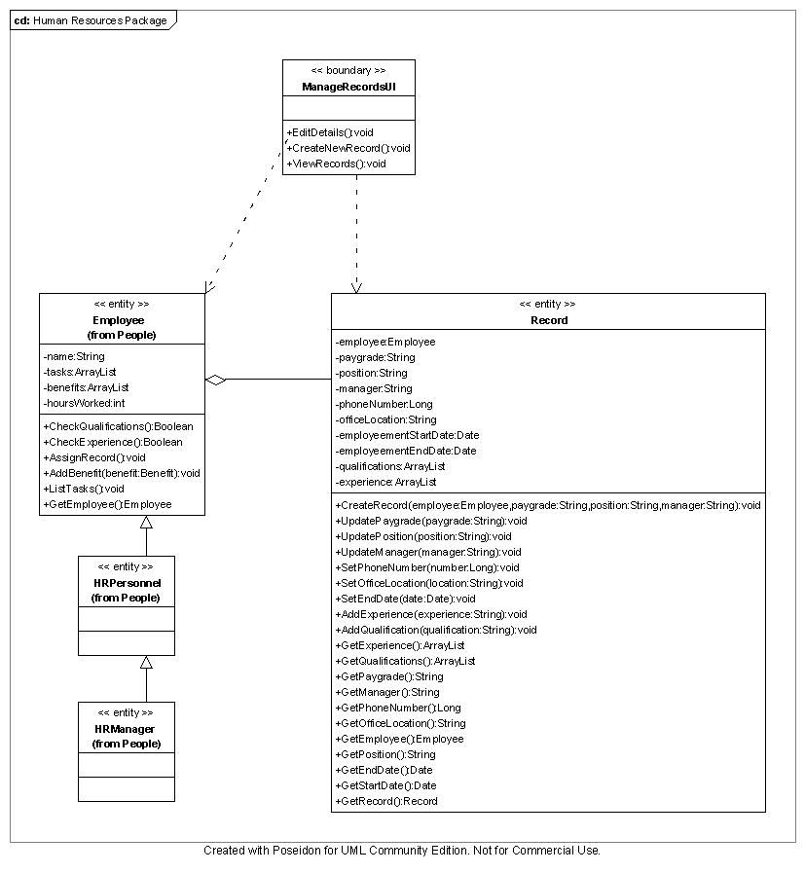

Payroll Package

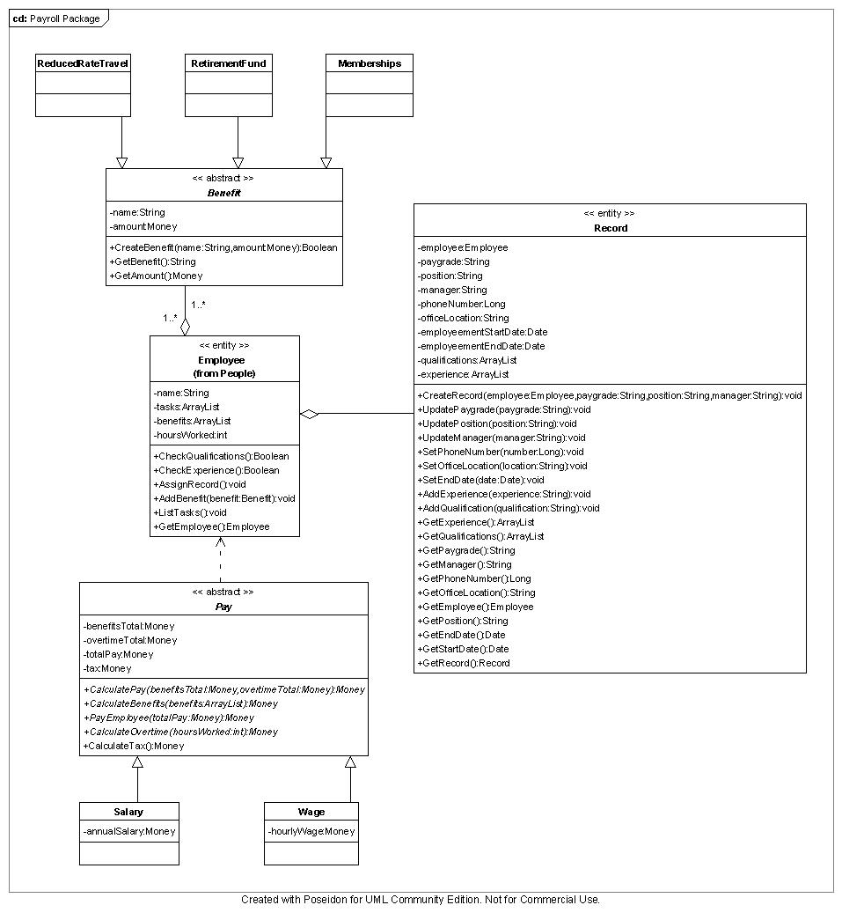

Interaction Diagrams

Class Specifications

Class - MainMenuUI

ManageTasks():void
This method will open the manage task user interface.

ManageRecords():void
This method will open the manage records user interface.

Class - ManageTaskUI

CreateNewTask():void
This method will create a new task based on a name and description entered into text boxes on the user interface.

DisplayTasks():void
This method will display all tasks.

EditDetails():void
This method will allow for changes to task details (status, description, assigned employees). It will call SetStatus(), UpdateDescription(), AllocateEmployee().

ViewAllocatedTasks():void
This method will display all of the tasks allocated to a particular employee.

AllocateTask():void
This method will allocate an employee to a task.

Class - ManageRecordsUI

ViewRecords():void
This method will display all records.

EditDetails():void
This method will allow for changes to record details (paygrade, position, manager, phoneNumber, officeLocation, employeementStartDate, employeementEndDate, qualifications and experience). It will call SetExperience(), UpdatePaygrade(), UpdatePosition(), UpdateManager(), SetPhoneNumber(), SetOfficeLocation(), and SetEndDate().

CreateNewRecord():void
This method will create a new task record base on an employee, paygrade, position and manager entered into text boxes on the user interface.

Class - Task

Attributes

name:String – The name of the task e.g. 747 oil check.
description:String – A short paragraph outlining the task details.
status:String – The current status of the task. Can be active, paused, or complete.
note:String – A note about the task. E.g. Waiting for new mould.
employees:ArrayList – A listing of all the employess assigned to the task.

Operations

CreateTask(name:String, description:String):Boolean
This method will create a task based on a name and description. It will return a true if a new task is created successfully or false if the task is not created.

AllocateEmployee():void
This method will assign an employee to a task.

GetStatus():String
This method will return the current status of the task.

SetStatus(status:String):void
This method will set the current status of a task. It will accept a string representing the status. The status can be active, paused, or completed.

GetDescription():String
This method will return the description for a task.

UpdateDescription(description:String):void
This method will update the description associated with a task. It will accept a string representing the updated description.

GetEmployees():ArrayList
This method will return all the employees allocated to the task.

GetName():String
This method will return the name of the task.

AddNote(note:String):void
This method will add a note to a task. It will accept a string representing the note to add.

GetNote():String
This method will return the note associated with the task.

GetTask():Task
This method returns the task.

Class - Employee

Attributes

name:String – The name of the employee.
tasks:ArrayList – A listing of all the tasks to which the employee is assigned.
benefits:ArrayList – A listing of the benefits allocated to the employee.
hoursWorked:int - The number of hours worked by an employee, used to calculate overtime.

Operations

CheckQualifications():Boolean
This method will check an employee’s record to see whether they have the required qualifications for a task. It will return true if the employee has the required qualifications or return false if they do not.

CheckExperience():Boolean
This method will check an employee’s record to see whether they have the required experience for a task. It will return true if the employee has the required experience or return false if they do not.

ViewTaskAllocation():ArrayList
This method will return the tasks to which an employee is assigned.

AssignRecord():void
This method will assign a record to the employee.

AddBenefit(benefit:Benefit):void
This method will add a benefit to an employee.

ListTasks():void
This method will list the tasks allocated to the employee.

GetEmployee():Employee
This method returns the employee.

Class - Record

Atttibutes

employee:Employee – The employee to whom the record belongs.
paygrade:String – The employee’s paygrade.
position:String – The employee’s position within the company.
manager:String – The employee’s manager.
phoneNumber:Long – The employee’s phone number.
officeLocation:String – The office location of the employee.
employmentStartDate:Date – The date the employee was first employed.
employmentEndDat:Date – The date the employee stopped working for the company (will only be set once the employ is gone. This is because employee records are not deleted when they stop work).
qualifications:ArrayList – A listing of all the employees qualifications.
experience:ArrayList – A listing of the employee’s experience.

Operations

CreateRecord(employee:Employee, paygrade:String, position:String, manager:String):Boolean
This method will create a record based on the employee, paygrade, position and manager. It will return true if the record is created successfully or false if the record is not created.

UpdatePaygrade(paygrade:String):void
This method will update the employee’s paygrade. It will accept a string representing the updated paygrade.

UpdatePosition(position:String):void
This method will update the employee’s position. It will accept a string respresting the updated position.

UpdateManager(manager:String):void
This method will update the employee’s manager. It will accept a string respresting the updated manager.

SetPhoneNumber(number:Long):void
This method will set the phone number of the employee. It will accept a long number resprenting the phone number.

SetOfficeLocation(location:String):void
This method will set the office location of the employee. It will accept string resprenting the office location.

SetEndDate(date:Date):void
This method will set the employment end date of the employee. It will accept a date representing the date.

AddExperience(experience:String):void
This method will add experience to an employee. It will accept a string representing the experience to be added.

AddQualification(qualification:String):void
This method will add a qualification to an employee. It will accept a string representing the qualification to be added.

GetExperience():ArrayList
This method will return all the experience that an employee has.

GetQualifications():ArrayList
This method will return all the qualifications that an employee has.

GetPaygrade():String
This method will return the paygrade of an employee.

GetManager():String
This method will return the manager of an employee.

GetPhoneNumber():Long
This method will return all the phone number of an employee.

GetOfficeLocation():String
This method will return all the location of an employee’s office.

GetEmployee():Employee
This method will return the employee to whom the record belongs.

GetPosition():String
This method will return the position of an employee.

GetEndDate():Date
This method will return the employment end date of an employee.

GetStartDate():Date
This method will return the employment start date of an employee.

GetRecord():Record
This method returns the record.

Class - Pay

Attributes

benefitsTotal:Money – The total cost of the benefits recived by the employee.
overtimeTotal:Money – The total amount of overtime recived by the employee.
totalPay:Money – The net pay packet of an employee. That is their gross income, minus benefits and tax, plus overtime.
tax:Money – The total tax payable by the employee.

Operations

CalculateBenefits(benefits:ArrayList):Money
This method will add up all of the employee’s benefits and store the amount as benefitsTotal.

CalculateOvertime(hoursWorked:int):Money
This method will calculate how much overtime the employee has worked and store the amount as overtimeTotal.

CalculateTax(totalPay):Money
This method will calculate the employee’s tax and store the amount as tax.

CalculatePay(benefitsTotal:Money, overtimeTotal:Money):Money
This method will deduct the total benefits from the employee’s pay and add any overtime to the employee’s pay then store the amount as totalPay.

PayEmployee(totalPay:Money):Money
This method will put the total pay into the employee’s bank account. This part of the system will interface with an external system which manages bank transactions.

Class - Benefit

Attributes

name:String – The name of the benefit. E.g. Gym Membership.
amount:Money – The total cost of the benefit.

CreateBenefit(name:String, amount:Money):Boolean
This method will create a benefit based on the name and amount. It will return true if a benefit is created successfully or it will return false if a benefit is not created.

GetBenefit():String
This method will return the name of a benefit.

GetAmount():Money
This method will return the amount of money a benefit is worth.

Summary

References

